Multi-platform report (adaptive vs responsive)

Responsive sites and adaptive sites are the same in that they both change appearance, based on the browser environment they are being viewed on. Both responsive and adaptive design have a very similar objective. They seek to provide the best possible experience on a single website when it’s viewed on a multi-platform (desktop, mobile, tablet devices). In this report, we will explaining the difference between responsive and adaptive design.

Responsive Design

Responsive design first coined by Ethan Marcotte in his book, Responsive Web Design. Responsive Design is the use media queries to serve different CSS allowing a site to change its appearance when viewed on different size screens. So in short it can be accomplished with just plain HTML and CSS. Responsive websites respond to the size of the browser at any given point. No matter what the browser width may be, the site adjusts its layout (any perhaps functionality) in a way that is optimized to the screen.

The key element that make up a Responsive website are CSS3, media queries, the @media rule, and fluid grids that use percentages to create a flexible foundation. It is also fundamental to use flexible images, flexible videos, fluid type and EM’s instead of pixels. All of these key points allow the responsive website to modify its layout to suit the device.

Responsive design is client-side which means the page is sent to the device browser (the client), and the browser then modifies the appearance of the page in relation to the size of the browser window.

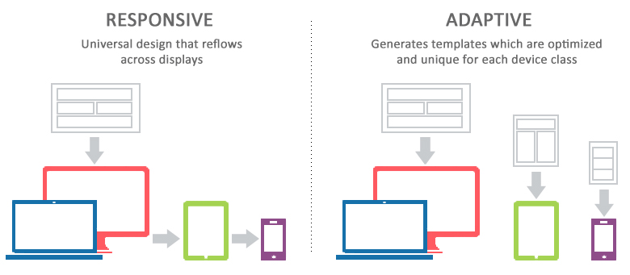

The pros of responsive web design:

1. User experience friendly

The responsive design can provide users with a friendly web interface, as it can adapt to almost all devices on the screen, including smartphones, tablets, TV, PC monitors, iPhone, and Android phones which contribute to the mobile friendly website design.

1. Save cost on responsive web design development

Comparing with the development for websites on PC, iPad, and mobile phone, the responsive design is more conducive to saving design and development costs. In term of design, it only needs to design two sets of design renderings for the responsive web interface based on the PC, iPad, and mobile. From the perspective of the front-end development, it only needs to develop three different sets of CSS styles. From the perspective of post-maintenance, there is no need to maintain PC interface, iPad interface, and mobile interface.

1. SEO friendly

It allows you to collect all social sharing links through a single URL address (if you are the site owner). You can make a positive contribution to creating better and friendlier websites. From another perspective, responsive web design is SEO friendly. Google also suggests giving priority to responsive design, because no matter what page version you choose, it’s easy for Google to deal with the same HTML and content.

The cons of responsive web design:

1. Bad compatibility for the old version of IE browser

If your site users are mostly using the old version of IE, it is not recommended to do responsive design. That’s a fatal problem for the older version of IE browser (IE6, IE7, IE8).

1. Slow down the loading

It will take longer to load for some responsive websites. It’s not a big deal because some unnecessary HTML/CSS will be loaded. For example, the images on a responsive site are just visually scaled down and not re-sized for fastest load times.

1. Time-consuming on the development

It’s a time-consuming task to a responsive website. If you intend to convert an existing site into a responsive website, it may take more time. If you want a new responsive website, it’s better to design from the very start. It means from creating the prototypes by prototyping tools to the HTML/CSS development.

1. Influence on the layout

The liquid layout of the responsive web design is hard for designers to control well about the design style. Designers are trying to display wireframe and design prototypes separately for mobile and desktop layouts. Only after these two layouts get improved, the responsive web design strategy can be really achieved.

Adaptive design

Adaptive design was introduced in 2011 by web designer Aaron Gustafson in his book, Adaptive Web Design: Crafting Rich Experiences with Progressive Enhancement. It is also known as progressive enhancement of a website. Adaptive design uses predefined layouts that have been carefully constructed for a variety of screen sizes. A particular layout is activated when the screen of the device viewing the website is detected and matched with a style sheet. In other words, the website is only concerned about the browser being a specific width, at which point it adapts the layout.

Adaptive design is predominantly server side. This means that the web server does all of the work of detecting the various devices and loading the correct style sheet depending on the attributes of the device. As well as the layout changing depending on the size of the screen they can also change depending on conditions like whether the device has a retina display or not.

The server can detect this and display high quality images for retina display devices like iPads and lower quality images for standard-definition displays.



The pros of adaptive design:

1. Faster page loads

Because adaptive delivery only transfers and displays the features that are required for the given device and optimizes all the content to the display’s size and resolutions specs, the page load much faster.

1. Optimized user experience

You can customize the page content and layout to improve UX. In other words, you have complete control over what content and assets are serve up. This is important given that many mobile and tablet users use a website for different purposes and engage in different ways than desktop users. When you create intuitive designs and give each user exactly what they want/need, your viewers are much more apt to revisit and ultimately, you will improve your conversion rate.

1. Improved SEO

Even though Google claims that does not favour any particular URL format, but many developers feel that some Google algorithms prefer adaptive design over responsive design. Any measures that developers can make their site easily navigable and Google-compliant will result in improved SERP visibility.

1. Serving a wider audience

When you use adaptive principles, you can deliver an experience that is appropriate for your user, even if they us a three- or four-gen old model. Adaptive design allows your site to still look good and function well on lower-end devices. This is particularly important if your audience is global, where the latest devices have limited availability.

The cons of adaptive website design:

1. Labour-intensive

Many developers shy away from AWD because there is a lot more groundwork to lay. Whereas RWD has only one HTML design, AWD has different HTML codes stored on the server that is delivered to the appropriate users and have to do more code that means more time and effort.

1. Professional required

AWD typically requires a solid team of professional developers that know how to handle the complexities of adaptive design. This can be a drawback for some small businesses with limited resources.

As the result, out team (team D) will use responsive design for our group project. One of the reasons why we choose responsive design because it is easier and takes less work to implement. It affords less control over the design on each screen size, but it’s by far the preferred method for creating new sites ate this moment. Responsive designers create a single design to be used on all screens and will generally start in the middle of the resolution and use media queries to determine what adjustments will be made for the lower and higher end of the resolution scale. This will tends make users happy, because that familiar web design seems guaranteed to translate across to any device’s screen.

<https://medium.muz.li/responsive-and-adaptive-design-69604ab1abd4>

<https://css-tricks.com/the-difference-between-responsive-and-adaptive-design/>

<https://www.uxpin.com/studio/blog/responsive-vs-adaptive-design-whats-best-choice-designers/>

<https://www.interaction-design.org/literature/article/adaptive-vs-responsive-design>

<https://www.mockplus.com/blog/post/pros-and-cons-of-responsive-web-design>

<http://mediumwell.com/pros-cons-adaptive-web-design-web-developers-need-know/>